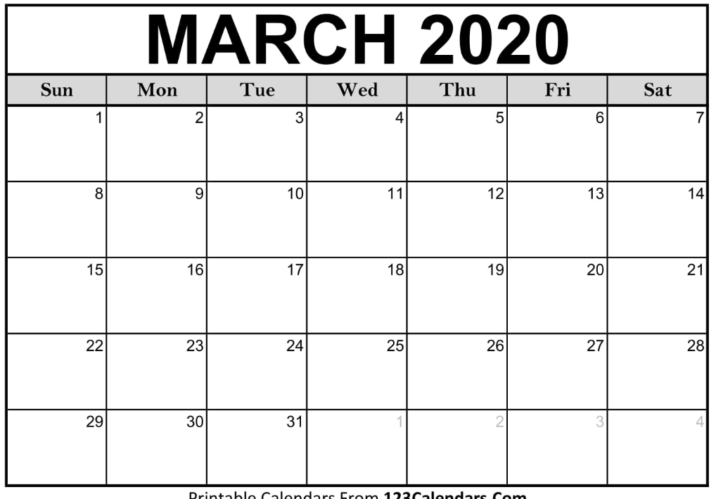

March 6: Parking benefit $46.25

March 13: Parking benefit $46.25

March 20: Parking benefit $46.25

March 27: Parking benefit $46.25

March total: $185